**Project design phase II Technology Architecture**

|  |  |
| --- | --- |
| Team ID | PNT2022TMID50737 |
| Date | 08 October 2022 |
| Project Name | Inventory Management System for Retailers |
| Maximum Marks | 4 Marks |

**Technology Architecture:**

Project shall full fill the following information in this technology architecture .

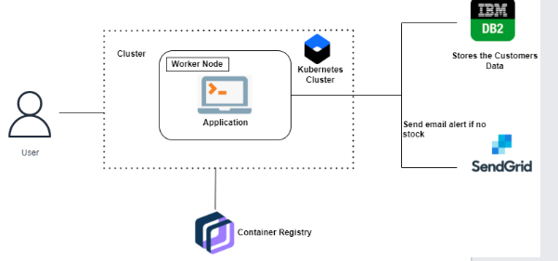

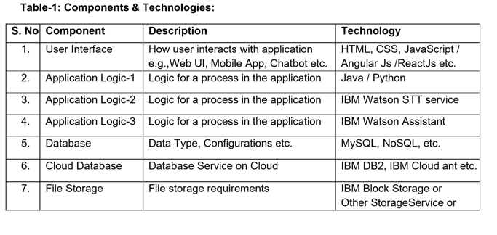

|  |  |  |  |
| --- | --- | --- | --- |
|  |  |  | Local Filesystem |
| 8. | External API-1 | Purpose of External API used in the application | IBM Weather API, etc. |
| 9. | External API-2 | Purpose of External API used in the application | Aadhar API, etc. |
| 10. | Machine Learning  Model | Purpose of Machine Learning Model | Object Recognition Model, etc. |
| 11. | Infrastructure  (Server / Cloud) | Application Deployment on Local System / Cloud Local Server  Configuration | Local, Cloud Foundry, Kubernetes, etc. |

**Table-2: Application Characteristics:**

|  |  |  |  |
| --- | --- | --- | --- |
| **S.NO** | **Characteristics** | **Description** | **Technology** |
| 1. | Open-Source  Frameworks | List the open-source frameworks used | Technology of  Opensource framework |
| 2. | Security Implementations | List all the security / access controls implemented, use of firewalls etc. | e.g., SHA-256,  Encryptions, IAM  Controls, OWASP etc. |
| 3. | Scalable Architecture | Justify the scalability of architecture  (3 – tier, Micro-services) | Technology used |
| 4. | Availability | Justify the availability of application  (e.g., use of load balancers, distributed servers etc.) | Technology used |
| 5. | Performance | Design consideration for the performance of the application (number of requests per sec, use of Cache, use of CDN’s) etc. | Technology Used |